LAB 1 · LAB REPORT
Build Your Lab
Complete this file as you work through the Lab 1 guide, then submit it to D2L.
Name | Devin Collins
Canisius e-mail | collin98@my.canisius.edu
Date submitted | 9/1/2026
Lab section / CRN | CYB 540L
Path (VM or codespace) | VM

How to use this template. Keep this file open next to the Lab 1 guide and fill in each section as you get to it. Every evidence box says what goes in it on each path: a screenshot, or pasted terminal output where the guide says text is fine. Answer every question in your own words, and note your path in the table above. Submit this file, not the guide, to the D2L dropbox.
Make your evidence count. Each screenshot or pasted terminal block should show your own prompt, with your username and hostname visible, so it is clear the work is from your machine. Evidence cropped to hide this may not receive credit.

Part 1: Get your machine running
Evidence. VM path: your VM running the Ubuntu desktop, with the VM name visible in the hypervisor window. Codespace path: the output of uname -a and ip addr from the codespace terminal.
sud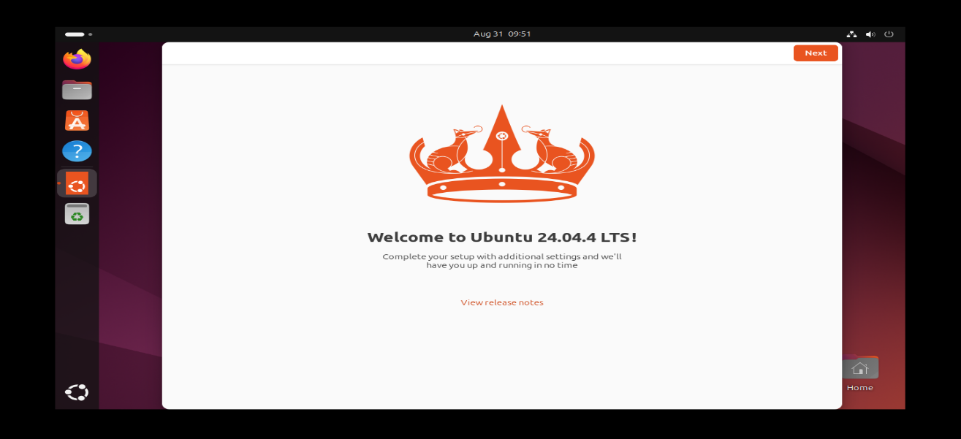
Q1. VM path: what did you name your VM, and which hypervisor did you use (VirtualBox, VMware, or UTM)?
The virtual Machine I created was called cyb540-ubuntu, and the hypervisor I used was VirtualBox.
Q2. VM path: you set the network adapter to Bridged. What does bridged mode do for your VM’s address?
The bridged mode puts the VM directly on my physical network as its own device, so my router assigns it an IP address like how my phone or laptop would have one.

Part 2: First updates and tools
Evidence. Your terminal after sudo apt upgrade, with your username and hostname showing in the prompt.
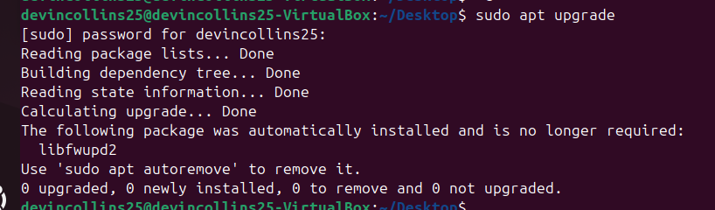
Evidence. The output of ip addr.
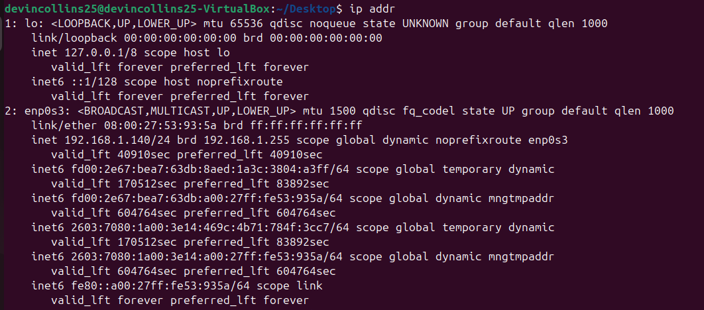
Q3. What is your machine’s IPv4 address (the inet line under your main adapter, not 127.0.0.1, and in a codespace not docker0)?
192.168.1.140
Q4. What does sudo do, and in which file are sudo commands logged?
Sudo lets a permitted user run a command with root privileges. Sudo commands are logged in /var/log/auth.log

Part 3: Basic hardening
Evidence. VM path: sudo ufw status showing the firewall active with OpenSSH allowed.
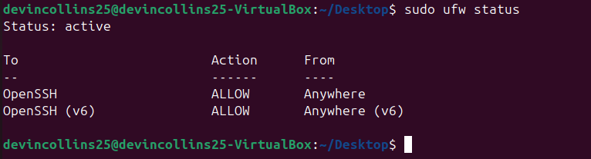
Evidence. VM path: a successful SSH login from your host to the VM using your key.
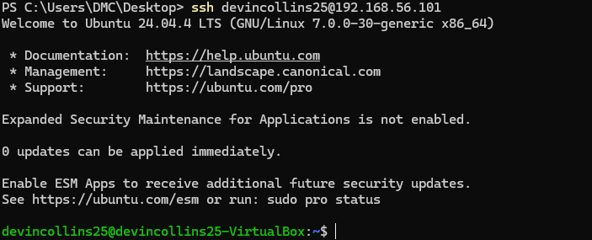

Q5. Why does the guide have you copy your SSH key and confirm it works before turning off password login?
You copy and test the SSH key first, so you know key-based login works before disabling password login. If not, you could lock yourself out of the VM.
Q6. Which two settings does the guide change in sshd_config, and what does each one stop?
PasswordAuthentication no – stops users from logging in with a password.
PermitRootLogin no – stops direct SSH login as the root user.

Part 4: Docker and the course repository
Evidence. VM path: the output of docker run hello-world.
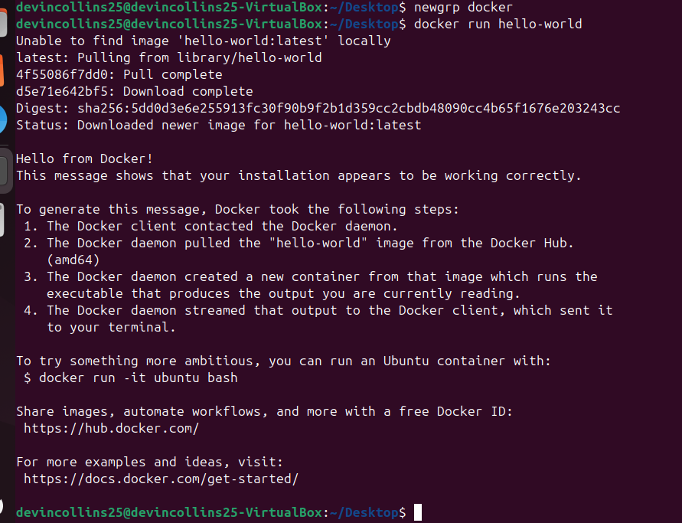
Evidence. The docker compose up success banner from the lab1 folder.
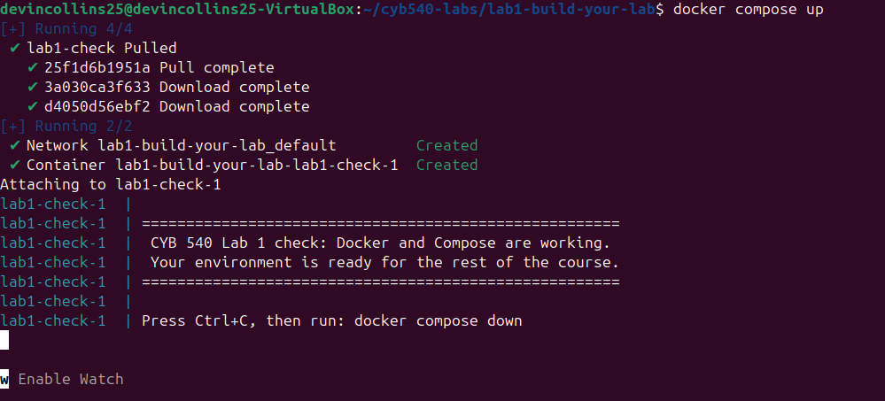
Q7. What did the course repository give you? One or two sentences.
This repository gave me docker-compose.yml, harden.sh, and README.md. docker-compose.yml defines the check container, README.md explains the lab, and harden.sh is a script.

Part 5: Find and map your network
Evidence. VM path: your ip route output, with the default gateway line visible.
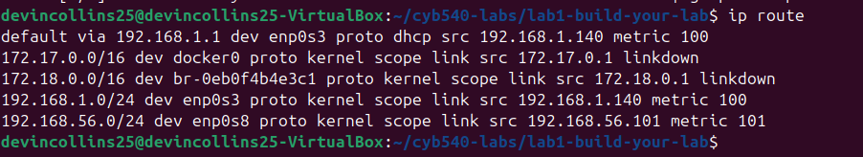

Evidence. Your nmap -sn results. Codespace path: run on your own computer; the ping broadcast plus arp -a fallback also counts.
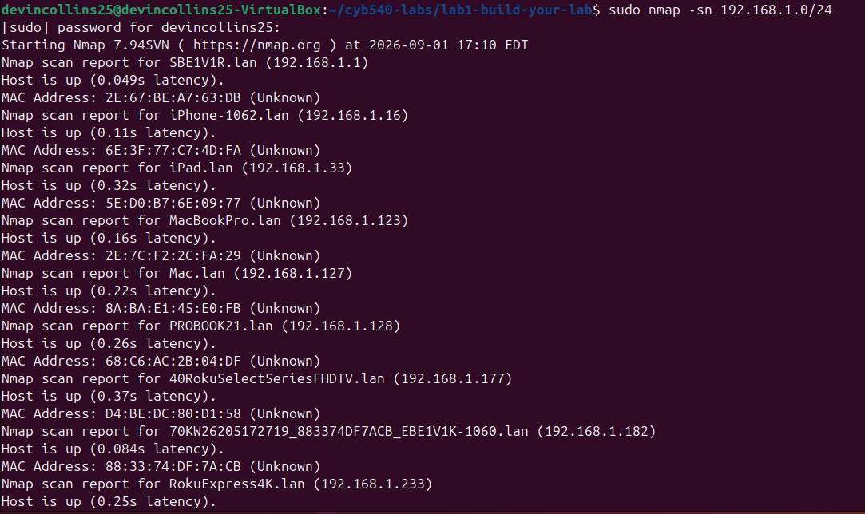

Evidence. Your finished network map from draw.io, with IP addresses labeled. Codespace path: include the codespace as a cloud node with its 10.0.x.x address.
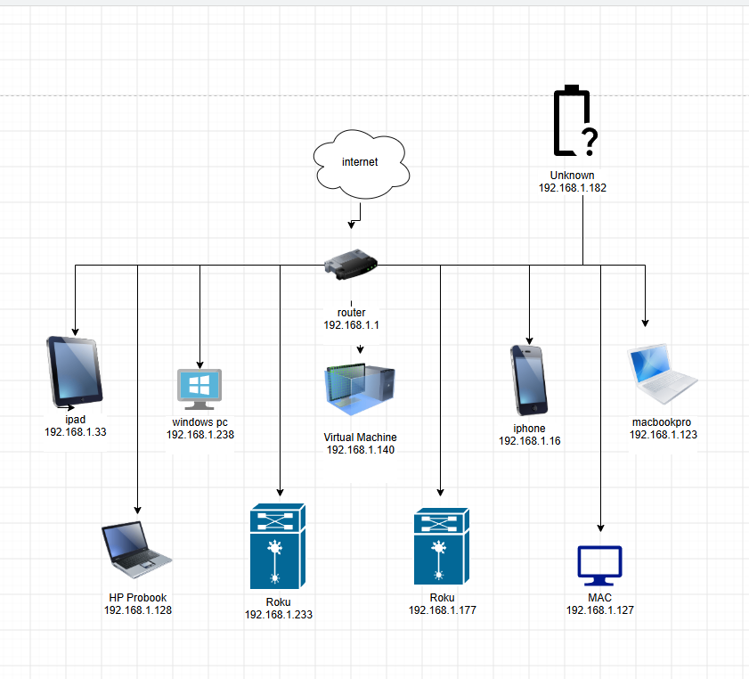
Q8. What is your default gateway address, and what is its job on the network?
192.168.1.1, The default gateway is the router and this sends traffic from my local network to other networks, such as the internet.
Q9. How many live devices did your sweep find on your network? List two of them by IP address.
My network sweep found 11 live devices. Two of them were 192.168.1.22 (ipad) and 192.168.1.238 (Windows PC)
Q10. Why does keeping a network map help you secure a network?
Keeping a network map helps secure a network because it shows what devices are connected. This makes it easier to find unknown devices, identify possible threats, and troubleshoot network problems.

Part 6: Your first packet capture
Evidence. One DNS packet (filter dns), with the name it looked up visible. Wireshark screenshot or pasted tshark output.
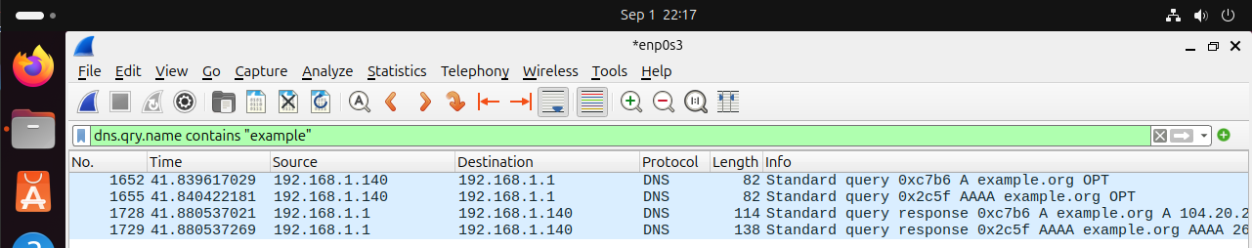
Evidence. One TLS Client Hello (filter tls.handshake.type == 1). Wireshark screenshot, or the tshark line showing the SNI.
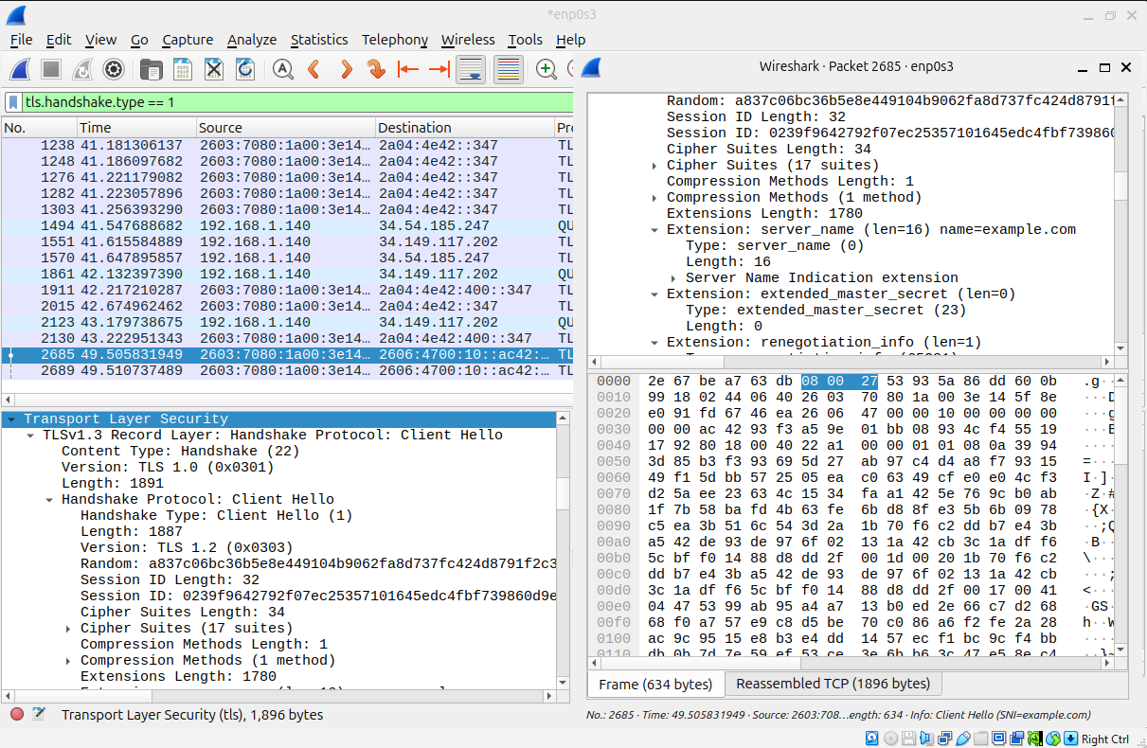
Q11. What domain did your DNS query ask for, and what address came back?
The DNS query asked for the domain which was example.com and the IP address from the response packet
Q12. You could read the DNS request but not the data after the TLS handshake. Explain the difference. One or two sentences.
DNS requests can often be read because they may be sent in plain text. After the TLS handshake, the data is encrypted, so Wireshark cannot read the actual communication.

Part 7: Save your way back
Evidence. VM path: your snapshot in the hypervisor, named "Lab 1 complete". Codespace path: one or two lines naming the Rebuild Container option and confirming you stopped your codespace.
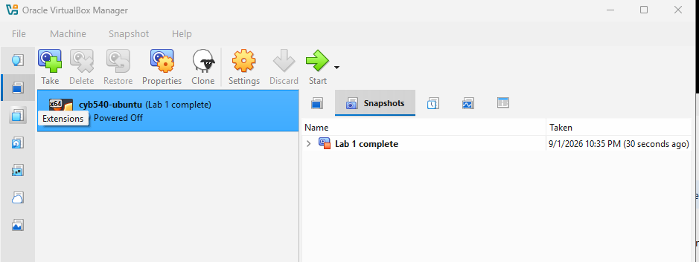
Q13. Why is it worth having a way back to a clean machine (a snapshot, or the rebuild recipe) before the later labs?
Having a snapshot lets you quickly restore the machine to a clean state if a later lab breaks something. This makes it easier to recover, just like a backup.

Wrap-up
Q14. What was the hardest part of this lab, and how did you work through it?
Ubuntu 26.04 would not boot up but figured out there was a bug with the hypervisor and the new .iso file. I tried to reduce CPUs, tried safe graphics, neither worked. I switched to 24.04 LTS and it installed first try. I emailed the professor, who as well confirmed it’s a known 26.04 display bug in VirtualBox.

Q15. Did anything surprise you or raise a question you want to explore? Optional.
N/A.

BEFORE YOU SUBMIT
(DONE) My name, e-mail, date, and path are filled in at the top
(DONE) Every evidence box has my own screenshot or pasted output, with my prompt visible. (DONE) I answered every question in my own words.
(DONE) My network map is included and labeled.
(DONE) I signed the statement below.
(DONE) I submitted this file to the D2L dropbox.

Statement of individual work
I confirm that this report is my own work and that every screenshot and pasted output comes from the environment I built for this lab.
Name: ______Devin Collins____________________________ Date: ___09/1/2026_____________

